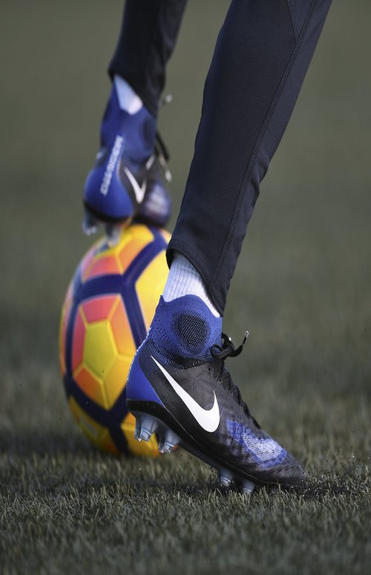

<https://thesolesupplier.co.uk/news/heres-your-complete-guide-to-buying-football-boots/>

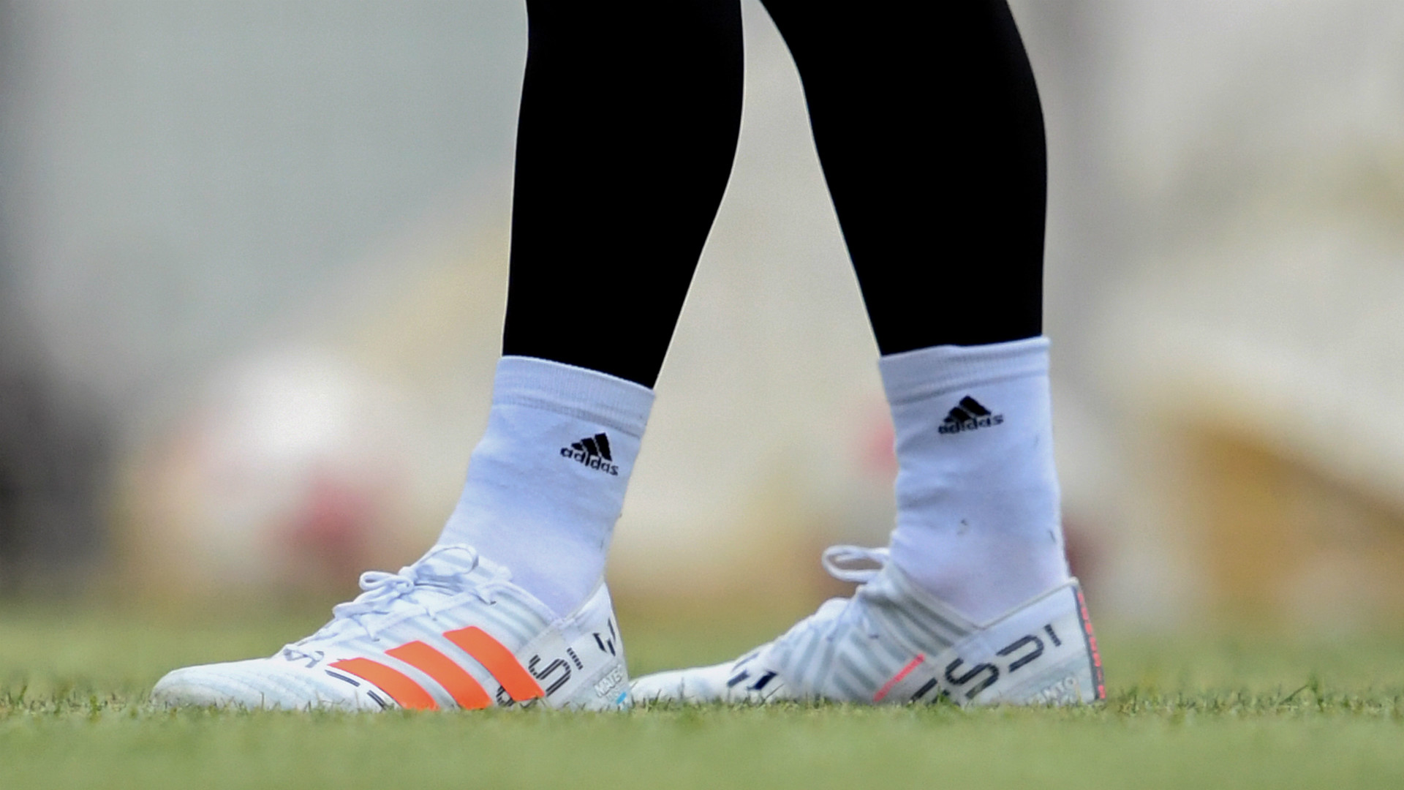

<https://www.goal.com/en-ie/news/football-boots-messi-ronaldo-neymar-wear/9pm0hvax7kppz1wykmhzbhbf>

1920 x 720

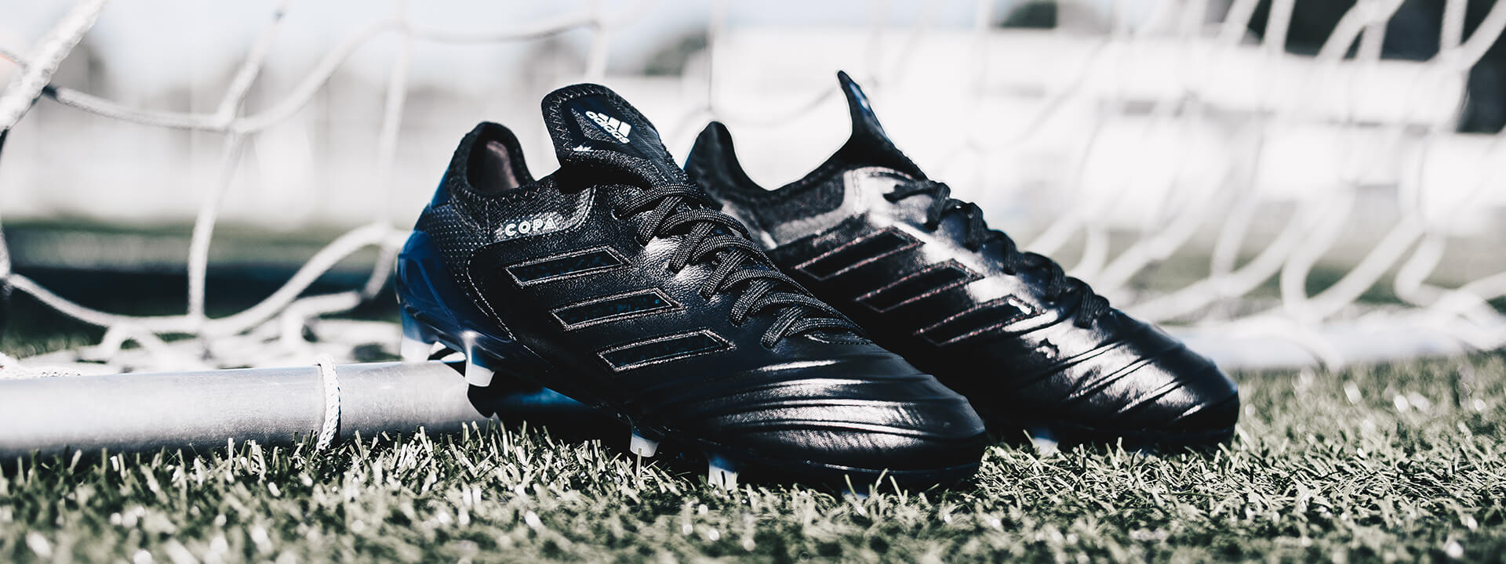

<https://www.voetbalshop.nl/blog/adidas-shadow-mode-pack>

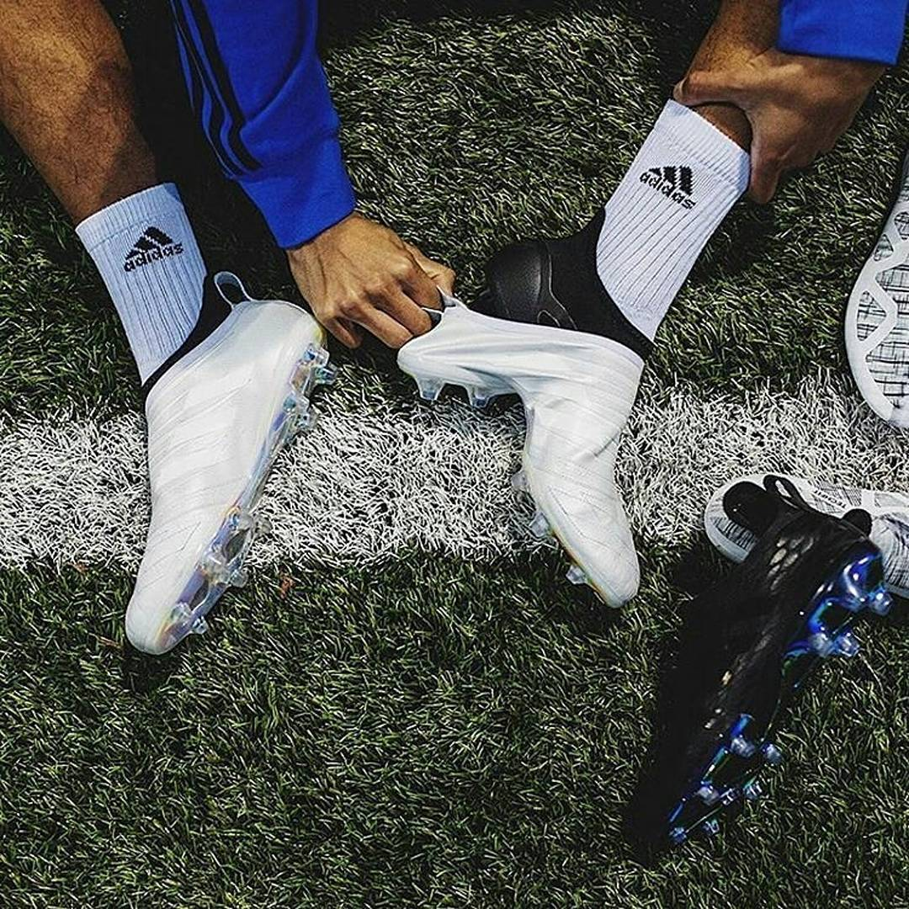

<https://thesolesupplier.co.uk/news/heres-your-complete-guide-to-buying-football-boots/>

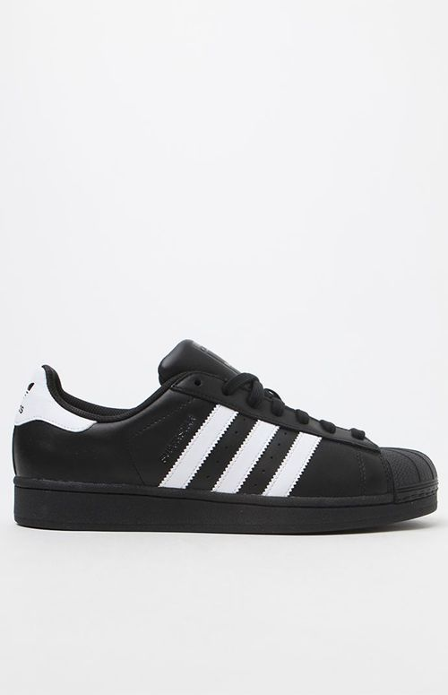

<http://www.explore-bigdata.fr/chaussures-adidas-superstar-bassetop-femme-noirblanche-p-613.html>

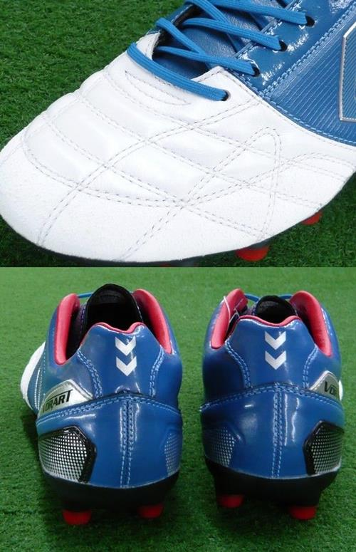

<https://spsheart.com/shop/products/detail.php?product_id=31>

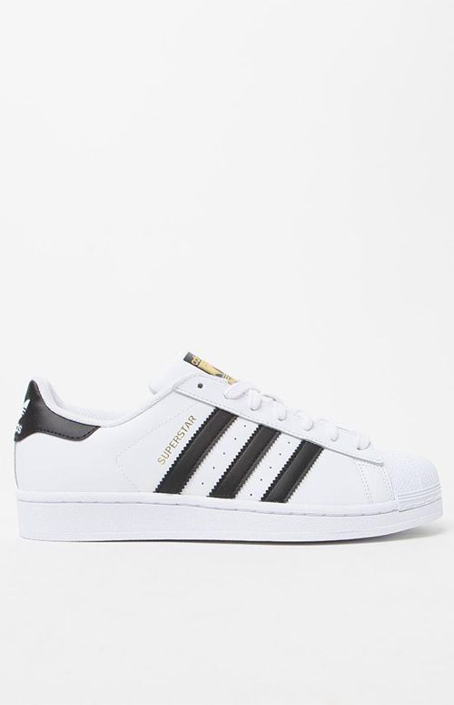

<http://www.dunderz.fi/naisten-badidasb-superstar-sneaker-lenkkarit-mustavalkoinen-p-517.html>

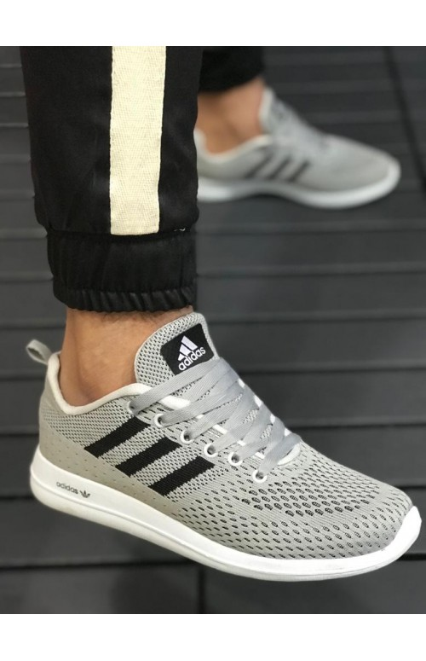

<https://www.sitilist.com/adidas-cloudfoam-element-race-spor-ayakkabi>

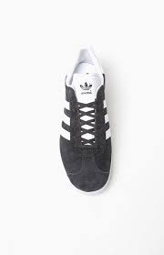

<http://www.billigenorge.com/?currency=AUD&main_page=product_info&products_id=1957>

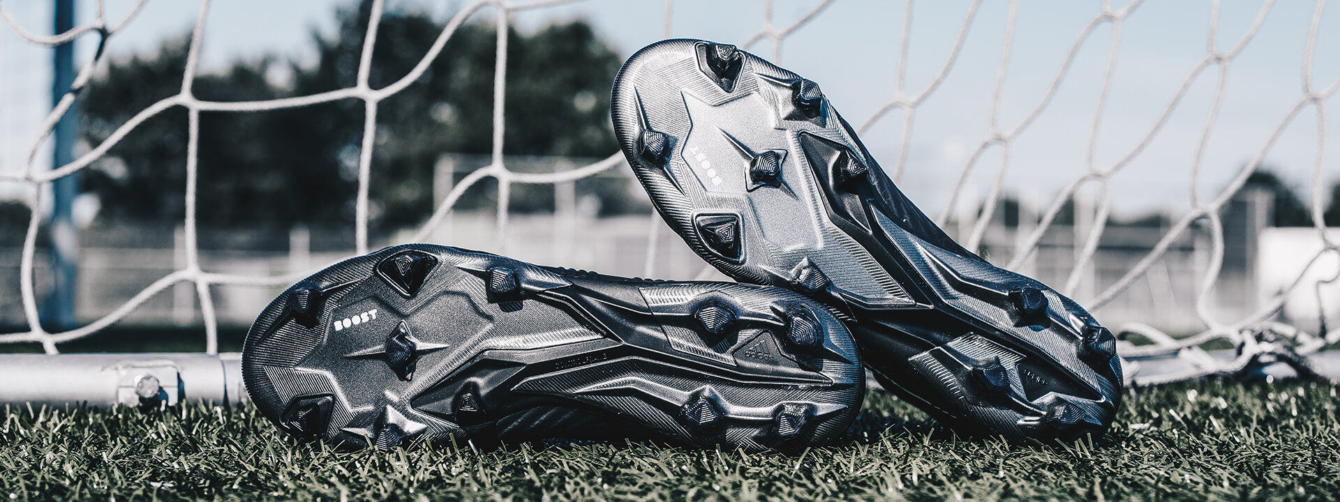

<https://www.voetbalshop.nl/blog/adidas-shadow-mode-pack>

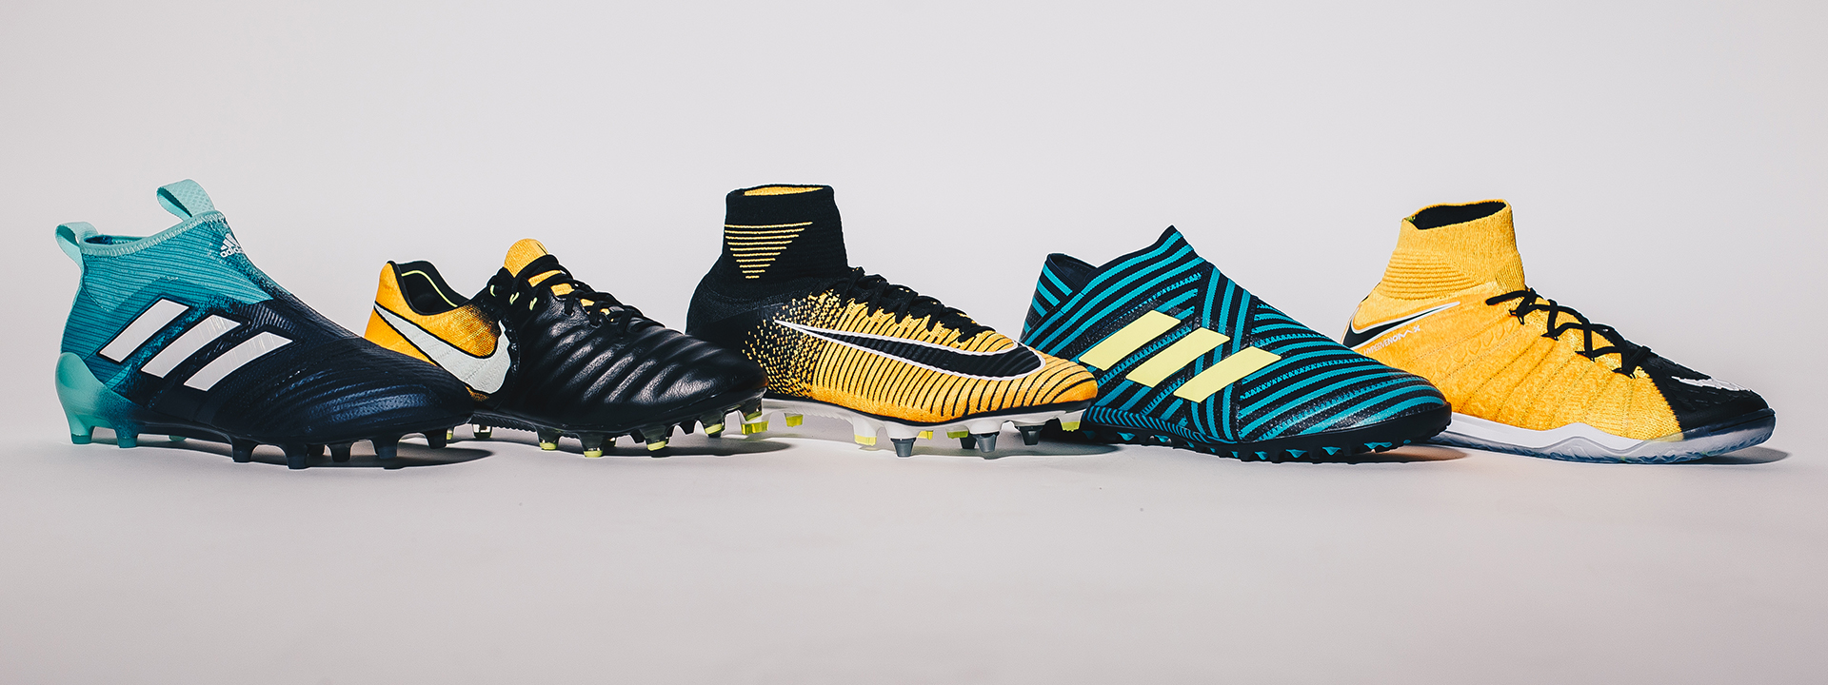

<https://www.voetbalshop.nl/blog/voetbalschoenen-gids>

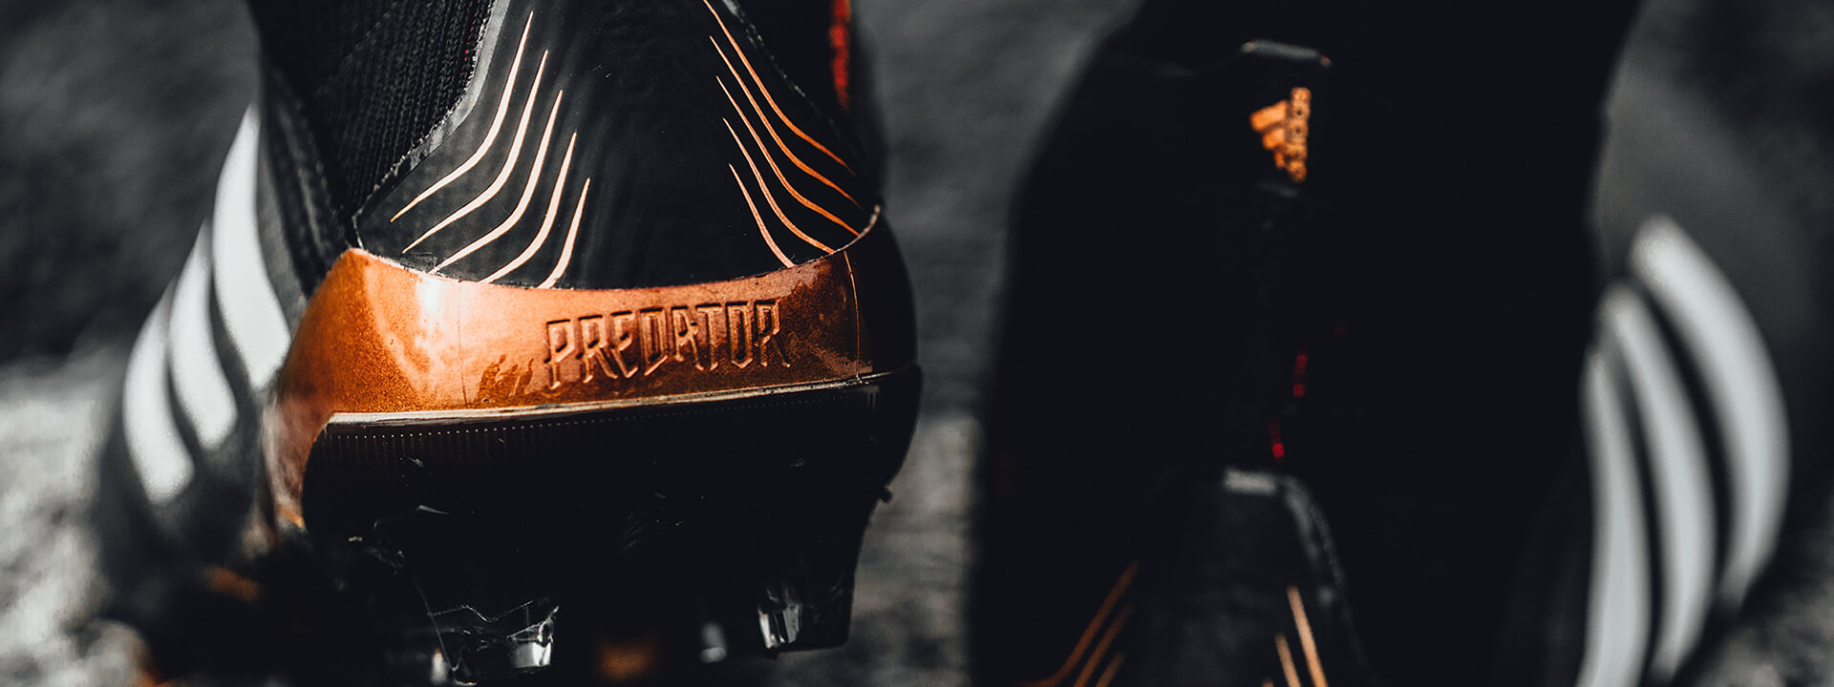

<https://www.voetbalshop.nl/blog/de-iconische-adidas-predator-is-back>